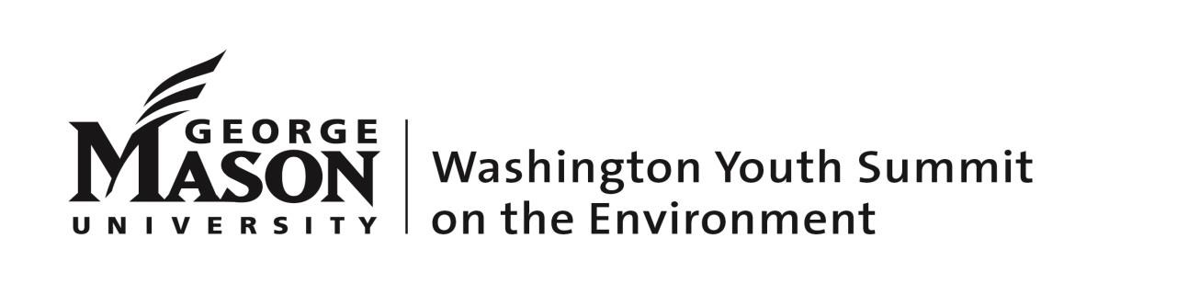
FACULTY ADVISOR POSITION

George Mason University and the Washington Youth Summit on the Environment (WYSE) seek several dynamic and enthusiastic individuals to fill the positions of Faculty Advisor for a week-long residential student leadership conference held June 26-July 1, 2022. WYSE brings together 300 of the Nation’s brightest rising high school juniors and seniors for an experiential and intensive conference focusing on leadership, environmental science, and conservation. The students will reside on the Fairfax campus of George Mason University, while taking advantage of Washington, D.C. and venues such as the National Geographic Society, the Smithsonian National Zoo, and the U.S. Capitol. Detailed program information and a tentative schedule can be found at www.wyse.gmu.edu.

Job Description:
The Faculty Advisor will be responsible for providing students with the best possible conference experience. Each Advisor will be assigned to a group of no more than 23 students and will facilitate the assigned curriculum and discussion topics, along with a Junior Faculty Advisor who in most cases is a WYSE alumni and current college student. The Faculty Advisor must be able and willing to interact in a large group setting and is responsible for the students’ safety and well-being at all times during the conference. Faculty Advisors reside in on-campus, single-room accommodations for the duration of the conference.

Job Requirements:
- Bachelor of Arts or Bachelor of Science degree, advanced degree(s) preferred
- Must be 21 years of age
- Ability to carry out the responsibilities listed above
- Interest in and knowledge of environmental science/conservation studies/sustainability/engineering or related field
- Experience and/or interest in working with high school students
- A high energy level, flexibility and the ability to work extended days and hours
- Ability to reside on campus at George Mason University for the entire conference work period
- Attend a mandatory paid training session immediately prior to the conference and participate in several conference calls leading up to the conference
- Pass a mandatory criminal background check
- Faculty Advisors are expected to be on campus from 4pm on Thursday, June 23, 2022 to the late-afternoon on Friday, July 1, 2022.

Compensation: Each Faculty Advisor will receive $2,200 plus single-room accommodations for the conference week and 3 training days prior to the conference (June 26-July 1, 2022). We expect the compensation to cover your travel and minimal meal costs during the conference.

Faculty Advisors are expected to be on campus from 4pm on Thursday, June 23, 2022 to the late-afternoon on Friday, July 1, 2022.

Application are due no later than February 18, 2022.

Interested candidates should review the conference details at www.wyse.gmu.edu then submit a letter of interest and resume, including references to:

Richard K. Friesner, Ph.D.
Program Director
Washington Youth Summit on the Environment
Email: rfriesne@gmu.edu
Phone: (703) 993-5010

